Dilay Selim
Exercises in Multimedia Web Design
INTRODUCTION TO JAVASCRIPT - Week 8

Exercise 1.4 — Student grade analyser
Given this array of student scores:
const scores = [42, 78, 55, 91, 63, 88, 34, 70, 95, 60];

Write code that:
1. Logs the total number of scores using .length.
2. Uses filter() to create an array of scores that are 70 or above (a pass).
3. Uses filter() to create an array of scores below 70 (a fail).
4. Uses map() to create an array where each score is scaled up by 5%.
(Multiply by 1.05 and use Math.round() to remove decimals.)
5. Uses find() to find the first score above 90.

Bonus: Use a for loop (or the reduce() method if you know it) to calculate
the average score. What is the class average?

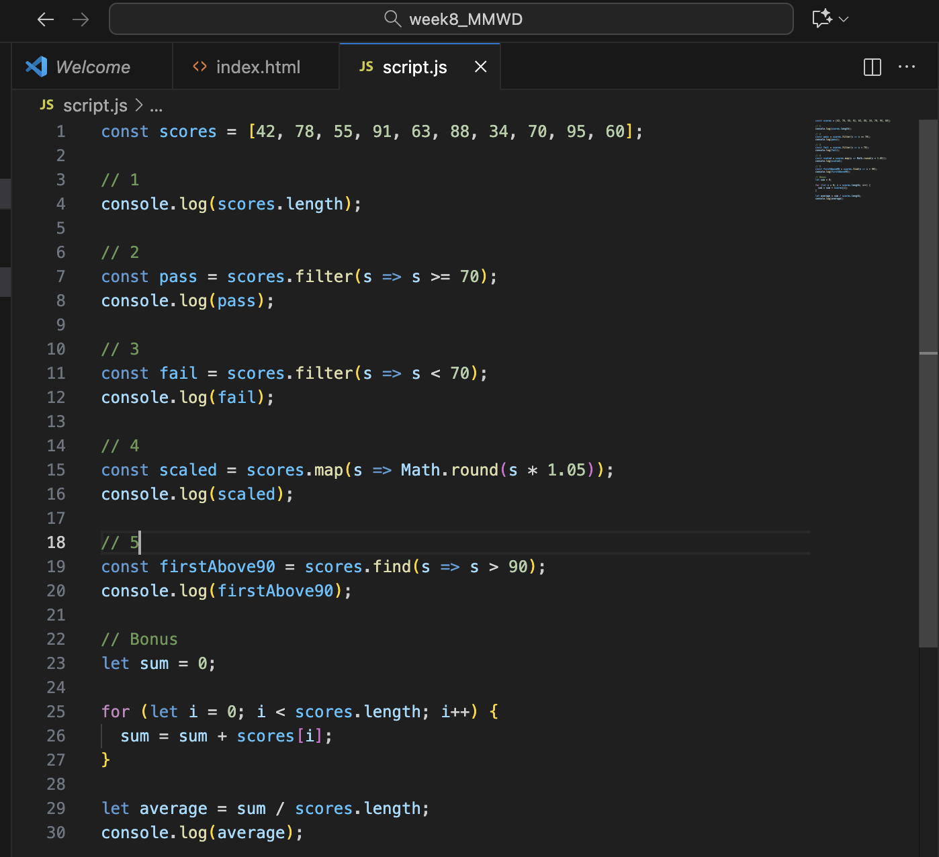

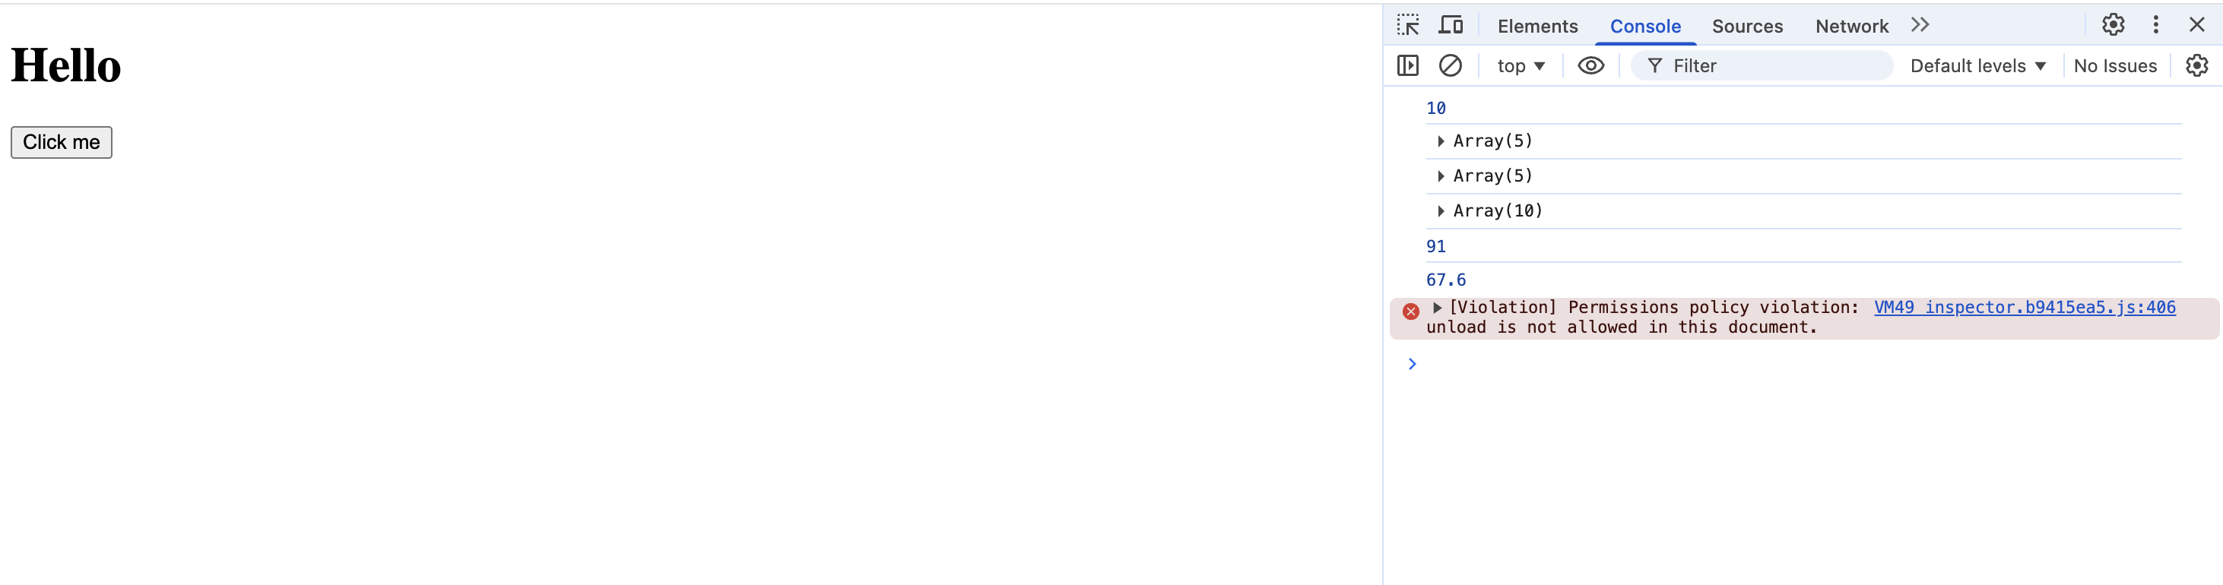

Note: The red message shown in the browser console is not related to the implemented code. It is caused by browser or extension behavior and does not affect the functionality or results of the exercise.

Exercise 2.4 — Library catalogue
Create an array called library containing at least four book objects.
Each book should have: title, author, year, and available (boolean).

Then write code that:
1. Logs the title of the first book using [0].title.
2. Uses filter() to get only books where available is true.
3. Uses map() to create an array of strings in the format:
"Title by Author (Year)" — use a template literal.
4. Adds a new book to the library using push().
5. Uses find() to locate a book by its title.

Bonus: Add a method called summary() to one of your book objects
that returns the formatted string using this.

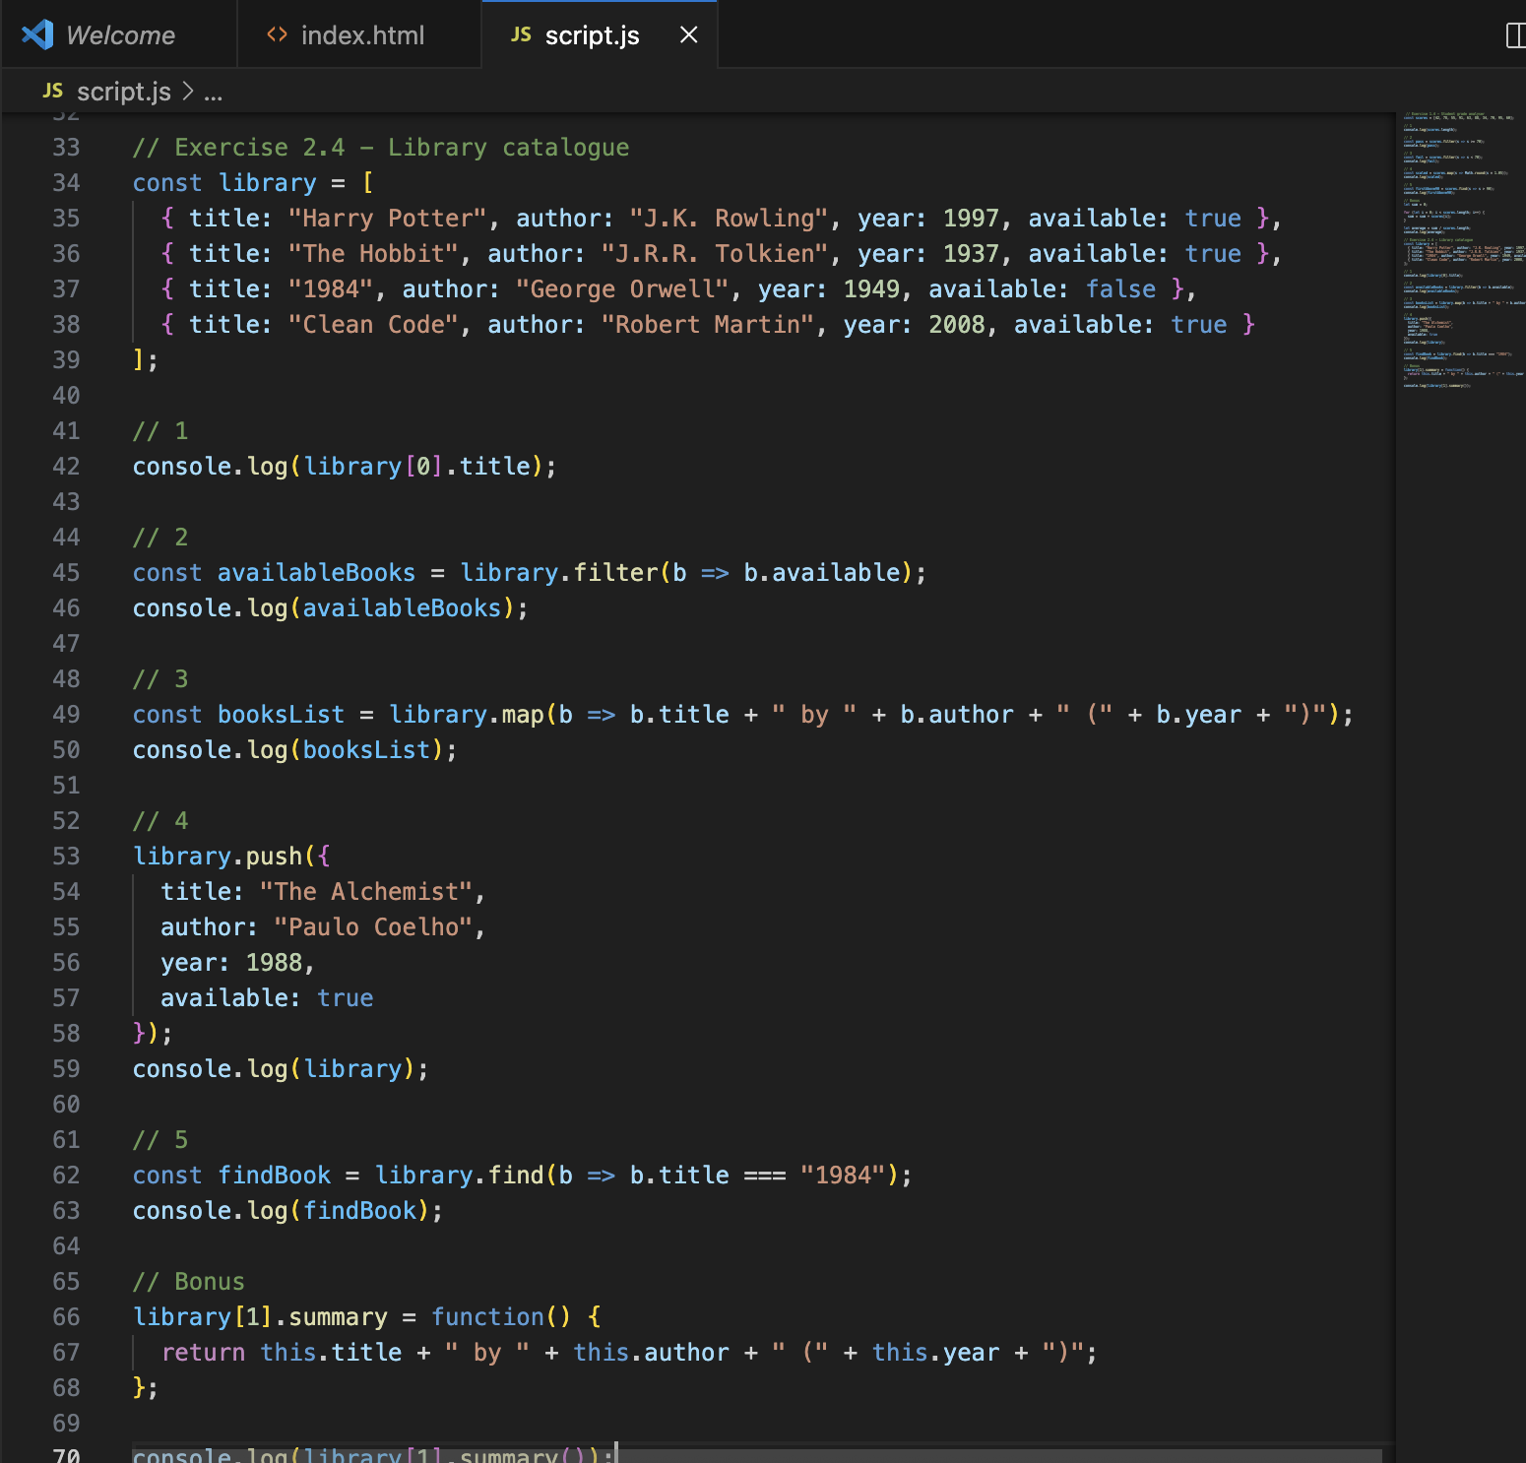

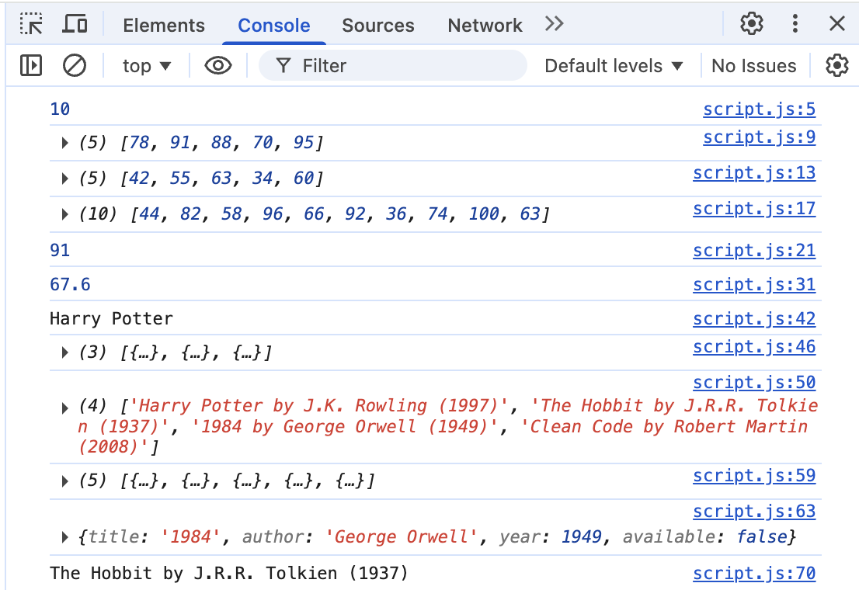

Exercise 3.4 — Dynamic product list
Given this array in script.js:
const products = [
{ name: "Laptop", price: 999 },
{ name: "Mouse", price: 29 },
{ name: "Keyboard", price: 79 }
];

Write JavaScript that:
1. Selects the <ul id="list"> element.
2. Loops through the products array with forEach.
3. For each product, creates a <li> element with the text:
"Laptop — $999" (using a template literal).
4. Appends each <li> to the list.
5. Changes the <h1 id="title"> text to "Product Catalogue".

Bonus: Products with a price over 500 should have their text colour
set to red using item.style.color.

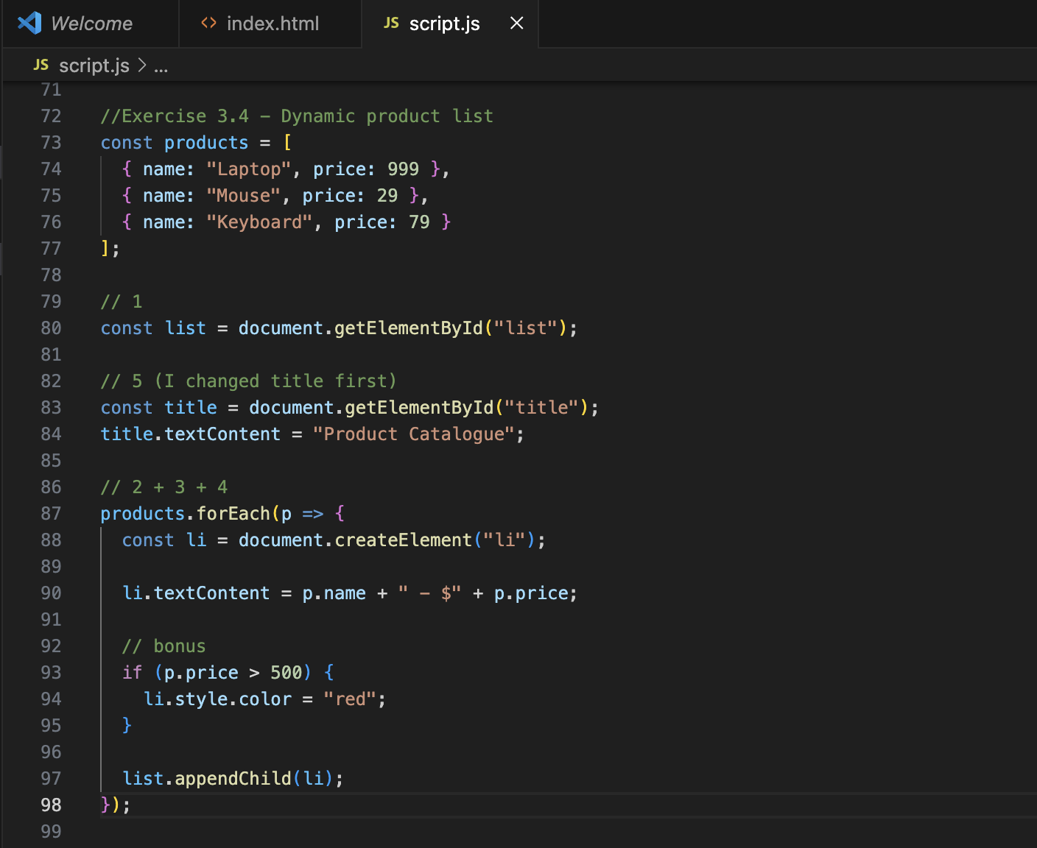
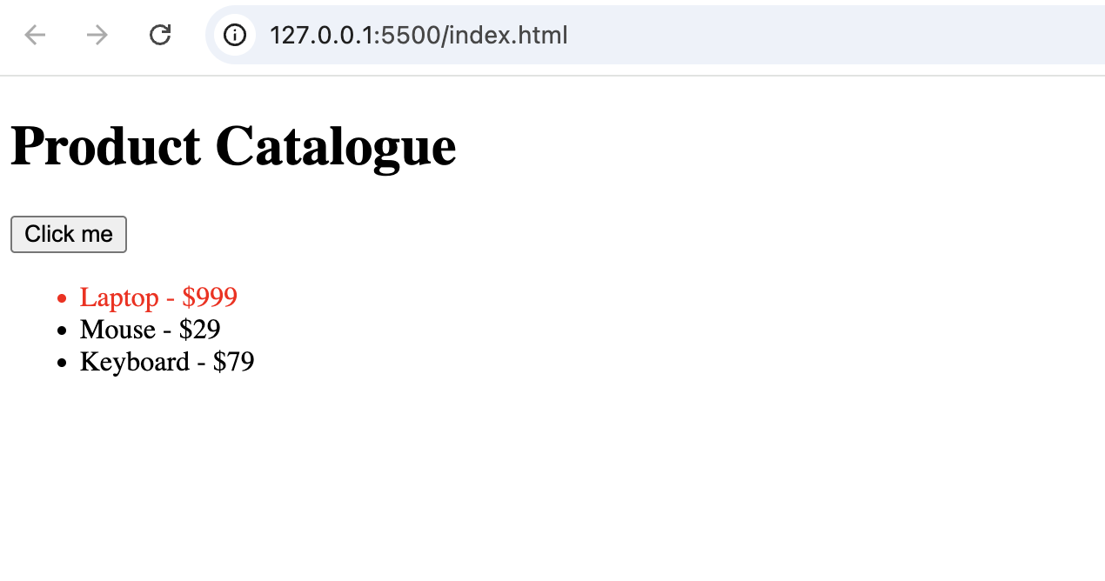

Solo Exercise 4.4 — Interactive to-do list
Build a simple to-do list. Add this HTML inside your <body>:
<input id="taskInput" type="text" placeholder="New task...">
<button id="addBtn">Add Task</button>
<ul id="tasks"></ul>

Then write JavaScript that:
1. When addBtn is clicked, reads the value from taskInput.
2. Creates a new <li> with that text and appends it to <ul id="tasks">.
3. Clears the input field after adding.
4. Does nothing if the input is empty (check with an if statement).
5. Uses event delegation on the <ul> so clicking any task marks it as
done (strike-through text).

Bonus: Also listen for the Enter key on the input so the user does not
need to click the button.

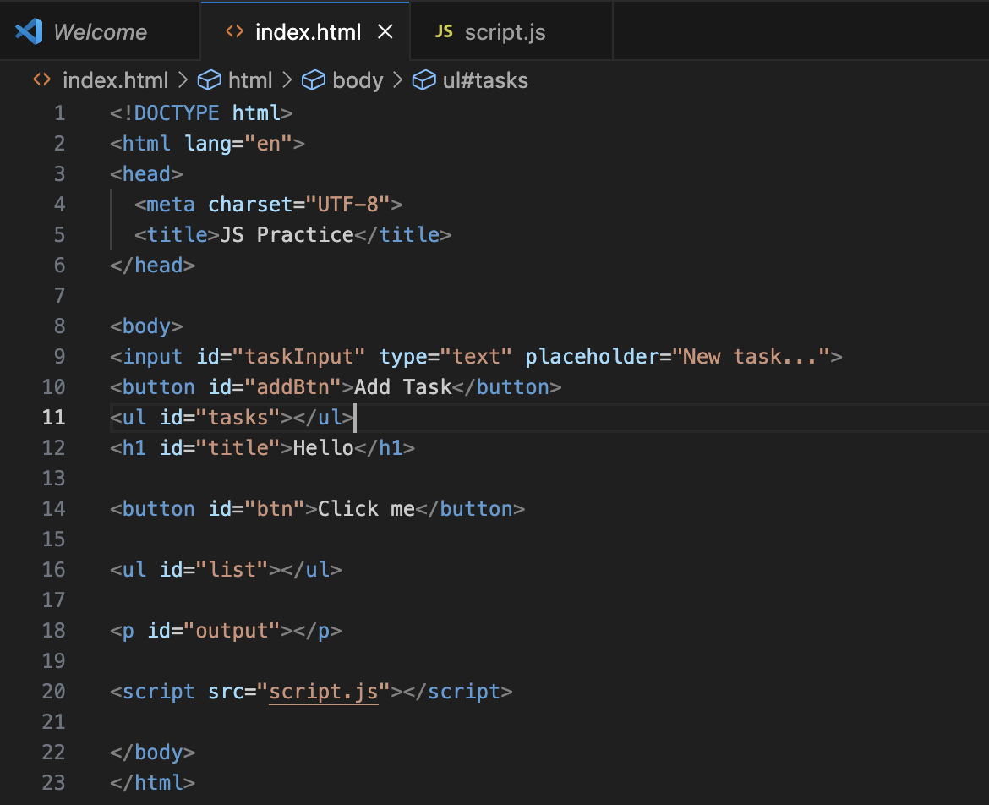

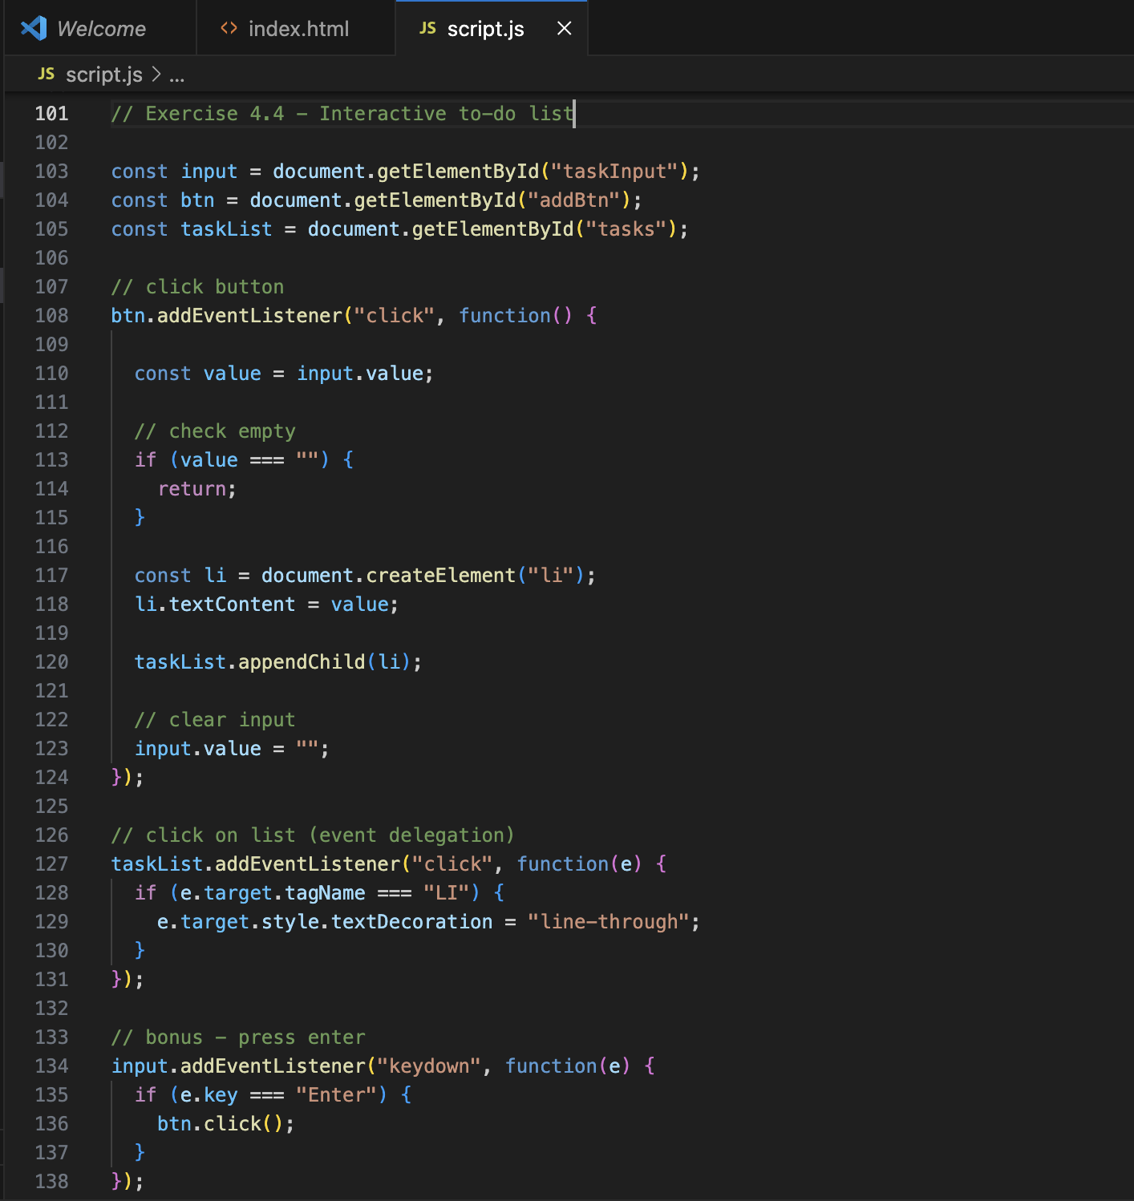
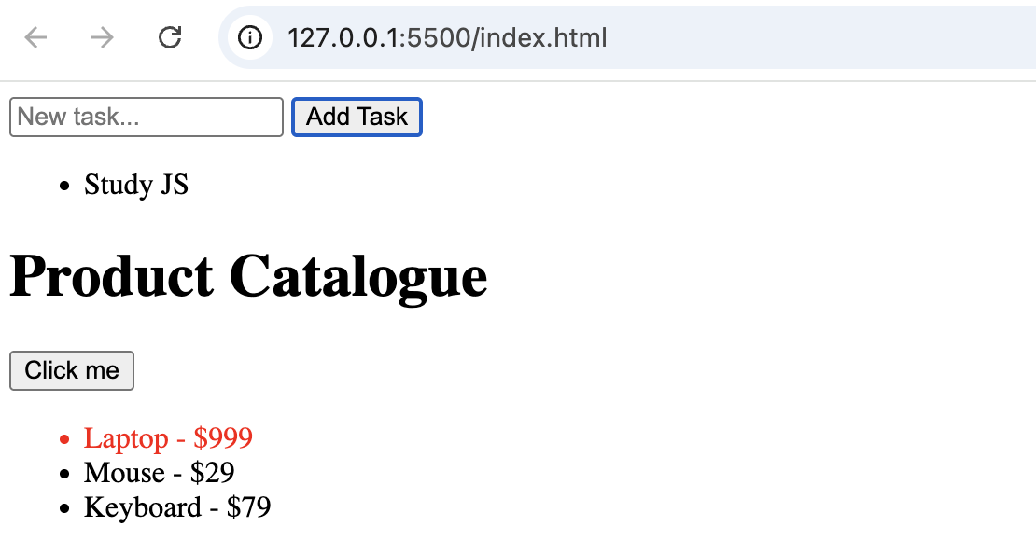
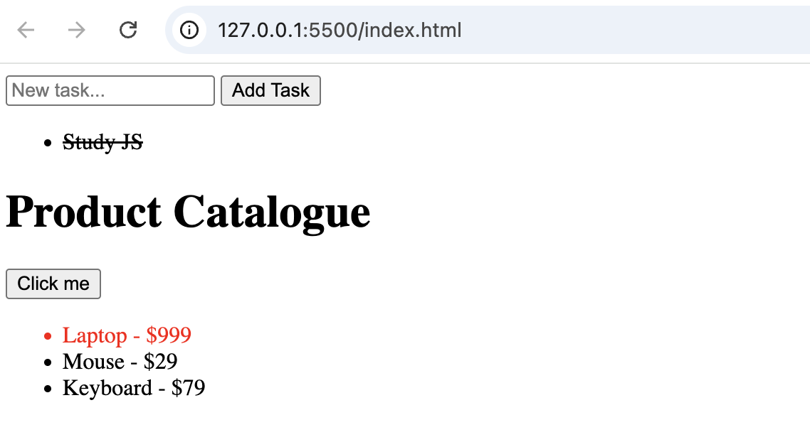
Solo Exercise 5.4 — User card generator
Use the JSONPlaceholder users endpoint:
https://jsonplaceholder.typicode.com/users

Write an async function called showUsers() that:
1. Fetches all users from the endpoint (returns an array of 10 objects).
2. Loops through the array with forEach.
3. For each user, creates a <li> and sets its text to:
"Name — email" (use a template literal with user.name and user.email).
4. Appends each <li> to <ul id="list">.
5. Updates <h1 id="title"> to show "10 Users Loaded".
6. Wraps everything in try/catch and shows an error message if the
fetch fails.

Bonus: Add a <button id="btn"> that calls showUsers() when clicked,
so the list only loads when the user asks for it.
